**Federal Contract # DTFH61-17D00001 – Task Order #1**

**LONG-TERM BRIDGE PERFORMANCE PROGRAM**

PROGRESS REPORT NO. 3

Report Period: December 1, 2017 – December 31, 2017

Prepared For:

**Federal Highway Administration**

Prepared By:



**A. Account of work performed in this period**

* 1. **Coordination and Meetings Between the Contractor, FHWA LTBP Team, and State Highway Departments**

The Rutgers team held a monthly conference call with Dr. Zobel on the 19th of December and submitted the minutes of the conference call on the 22nd of December.

* 1. **Data Gap Analysis**

Task 2.1: Examine, Characterize, and Summarize LTBP Protocols for Data Collection Efforts. Work continued on Task 2.1 for each of the four high priority performance issues ( Task 2.1.1 Untreated bridge decks, Task 2.1.2 bridge deck joints, Task 2.1.3 bridge bearings, and Task 2.1.4 treated bridge decks). This task and sub tasks focused on examining and structuring the data that may be obtained from all current LTBP data collection protocols pertinent to each high priority performance issue and is currently on schedule. The data collection protocols (both published and available drafts) were reviewed and summarized. As a result of this effort, a database of data sources has been compiled which aggregates each possible data source available per LTBP protocols into a single, searchable table. This table serves the basis for this tasks effort and is continuously being updated, as more metrics are available through this research and effort. The results of this task are in the process of being reviewed and error screened - see the Data Gap Appendix Task 2.1 for a sample summary analysis performed in Python (a free, open source programming language).

Task 2.2: Develop Set of Data Collection Needs. The Rutgers team have investigated the current best practices approaches to deterioration and other predictive modeling to identify useful data sources for each high priority performance issue (Task 2.2.1 Untreated bridge decks, Task 2.2.2 bridge deck joints, Task 2.2.3 bridge bearings, and Task 2.2.4 treated bridge decks). In general, data is needed to characterize both “inputs” and “outputs” related to each of the data use cases. For example, data that would be considered “inputs” would be effective at characterizing or quantifying the following types of influence (1) design, (2) construction, (3) environment, (4) live load, and (5) maintenance and preservation. In addition, data that would be considered “outputs” would be performance metrics and could range from simple condition ratings to more quantitative NDE metrics. A detailed examination of the literature has begun in December and is anticipated to be finished in January.

Task 2.3: Identify Data Gaps and Collection Strategies. Per the Task 2 schedule, the primary work on this task is expected to begin in January.

Task 2.4: Prioritization and Strategic Recommendations. Per the Task 2 schedule, the primary work on this task is expected to begin in February.

Project Engineer: 157.50 hours

Staff Engineer: 39.50 hours

Project Support: 13 hours

* 1. **Communication**

The Rutgers team prepared the electronic version of the monthly progress report and submitted it to FHWA. Moreover, the Rutgers team developed a MS Project file showing the project milestone and submitted it to FHWA.

**B. Work to be accomplished during the next period**

* 1. **Coordination and Meetings Between the Contractor, FHWA LTBP Team, and State Highway Departments**

The Rutgers team will reach out to FHWA to schedule a meeting with Dr. Zobelin January and will submit the meeting minutes shortly after the meeting.

* 1. **Data Gap Analysis**

Task 2.1: Examine, Characterize, and Summarize LTBP Protocols for Data Collection Efforts. The Rutgers team will continue working on Task 2.1 throughout January. Detailed characterization of the available data sources for each high priority performance issue will be summarized and discussed following an internal review of the data sources compiled. The example summary presented in Data gap Appendix Task 2.1 below will be expanded and completed for each high priority performance issue.

Task 2.2: Develop Set of Data Collection Needs. The literature review which began in December is anticipated to be finished in January. This literature review aims to identify all current and relevant best practices approaches to deterioration and other predictive modeling. In addition to the information provided by the literature review, the set of data collection needs will be formulated in conjunction with the Rutgers research team developing the Strategic Research Matrices as well as several industry leaders. Based on this work and collaboration, a comprehensive set of data needs (inclusive of both “inputs” and “outputs”) required to realize each of the four use cases is expected to be completed in January.

Task 2.3: Identify Data Gaps and Collection Strategies. In this task, the current LTBP data collection protocols identified in Task 2.1 and the desired data identified in Task 2.2 will be compared to establish any gaps present in the current LTBP data collection protocols. The unmet data needs will then be ranked and prioritized by (1) the consequences of foregoing data collection in terms of failing to realize one of the use cases, and (2) metrics such as cost, ease of data collection (feasibility), availability, effectiveness (in terms of model prediction), etc. The primary work on this task is expected to begin in January upon completion and internal and external review of Task 2.2 discussed above.

Task 2.4: Prioritization and Strategic Recommendations. Per the Task 2 schedule, the primary work on this task is expected to begin in February.

* 1. **Communication**

The Rutgers team will prepare the electronic version of the monthly progress report and will submit it to FHWA. Moreover, the Rutgers team will submit the updated MS Project file to FHWA.

**C. Problems/Recommended Solutions**

No problems encountered during this period.

**D. How the results of the work performed supports one or more of the FHWA, DOT and LTBP Goals**

All of the work conducted under this task order aims to ensure that the LTBP program collects the data required to realize the following four use cases: (1) Advance research in bridge deterioration and predictive modeling, (2) Advance research in cost analysis, (3) Support improved bridge design methods, and (4) Quantify the effectiveness of bridge maintenance, preservation, repair, and rehabilitation strategies. These use cases encapsulate the overarching goals of the LTBP program and its vision for positively impacting the practice of bridge engineering.

**E. Purchases and Rentals**

Nothing was purchased or rented during this period.

**F. Travel Details for Reporting Period**

No travel occurred during this reporting period.

**G. Current and Cumulative Expenditures (cost shown includes benefits and overhead)**

|  |  |  |
| --- | --- | --- |
| **Institution** | **Current Expenditures**  **12/1/2017 – 12/31/2017** | **Cumulative Expenditures**  **10/1/2017 – 12/31/2017** |
| Rutgers, the State University of New Jersey | $ 23,654.00 | $ 73,371.50 |

# Data Gap Appendix Task 2.1

# LTBP Data Gap - Protocol Characterization & Summary

The primary purpose of this data gap analysis is to determine if there are data that are not currently specified for collection within LTBP protocols, but that should be considered for inclusion. For each high priority performance issue, the four driving data use cases (summarized as (1) Advance research in deterioration and predictive modeling, (2) Advance research in cost analysis, (3) Support improved design methods, and (4) Quantify the effectiveness of maintenance, preservation, and rehabilitation strategies) will be used to assess the current data collection protocols. Specifically, the influences on the performances (which may be categorized as data type sources related to design, construction, environment, live load, materials, and maintenance) relevant to each data use case will be identified through a review of the literature and established predictive models. In a similar manner, the available performance metrics relevant to each of the data use cases (termed “outputs”) will also be identified. Mapping these inputs and outputs against the LTBP data collection protocols will permit the identification of any unmet data needs. These needs will then be prioritized and used to develop a series of recommendations to the LTBP program.

## Overview of LTBP Data Collection

The data collection protocols (both published and available drafts) were reviewed, characterized, and summarized into a database of data collection sources. This database attempts to aggregate each possible data source available per LTBP protocols into a single, searchable, and highly customizable data set. These data sources may then be filtered and sorted in a variety of ways to provide a basis for identifying, categorizing, and understanding what data is being collected in the LTBP program and how this data maps to the program's data collection goals.

The database may be searched by the primary, secondary, or tertiary LTBP protocol group or group number, by the specific data type collected, or by a variety of other extensible “tags” that are used to provide a general characterization as to the nature of the data source as well as provide a relational link between other possible descriptive tables. Emphasis was also paid to the logical grouping of these data types as well so as to provide a complete ‘picture’ of each data collection effort and how it aids or relates to each high priority performance issue. For example, the LTBP protocol EDBD005 involves collecting bridge inspection records inclusive of inspection information, data, documents, and images from previous inspections. This specific protocol was entered into the database and tagged as having “Design”, "Live Load", and “Maintenance and Preservation” data type attributes.

The following sections use the robust [Pandas](https://pandas.pydata.org/) scientific library to examine the database created for Task 2.1 of the LTBP Data Gap Analysis. Pandas is an open source, BSD-licensed library providing high-performance, east-to-use data structures and data analysis tools for the [Python](https://www.python.org/) programming language. This exampled is intended to demonstrate (1) the general content of the data collection summary data base, (2) one method of extracting the data for analysis, and (3) a simple overview of the data sources collected

Note that the raw data and analysis shown here are preliminary and as such have not yet been checked and verified.

### Import data collection database

Import the 'Data Collection Summary' table from the main database (from an excel file to a Pandas dataframe) and preview the contents. Note that the main representation of the database is kept as an Excel file due to the familiarity many Engineers have with this format. However, it is also maintained in a variety of different formats (e.g. sqlite3, xml, etc.) to make the information available to various different analysis approaches and methods.

In [1]:

%matplotlib inline  
import numpy as np  
import pandas as pd  
import matplotlib.pyplot as plt  
  
# read excel table as pandas dataframe  
df = pd.read_excel('../protocol-summary.xls', sheet_name='Data Collection Summary')  
  
# replace nans with empty strings  
#df = df.fillna('')  
  
# show the first few entries and structure of table  
df.head()

Out[1]:

|  |  |  |  |  |  |  |  |  |  |
| --- | --- | --- | --- | --- | --- | --- | --- | --- | --- |
|  | Primary Group | Secondary Group | Tertiary Group | # | Protocol Name | Data Collected | Notes | Data Type | Objective |
| 0 | PRE | ED | BD | 1 | Plans and Specifications for Bridge Design | Bridge Design and construction parameters and ... | NaN | Design | NaN |
| 1 | PRE | ED | BD | 1 | Plans and Specifications for Bridge Design | Bridge Design and construction parameters and ... | NaN | Construction | NaN |
| 2 | PRE | ED | BD | 2 | Bridge Construction Records | Data and information related to the original c... | NaN | Construction | NaN |
| 3 | PRE | ED | BD | 3 | Bridge Design and Construction Cost | Cost data related to the design and constructi... | NaN | Design | Cost Analysis |
| 4 | PRE | ED | BD | 3 | Bridge Design and Construction Cost | Cost data related to the design and constructi... | NaN | Construction | Cost Analysis |

### 

### View Summary of Data Collection Types

Note that each entry in this table contains information regarding the LTBP protocol group designation and the data type collected.

To view a total summary of the Previsit and Field Visit LTBP data collection protocols, we will first filter the imported table by the Primary Group, Secondary Group, and Data Type columns.

In [2]:

# columns to include  
cols = ['Primary Group', 'Secondary Group', 'Data Type']  
  
# filter main table based on desired columns  
tab1 = df.loc[:,cols]  
  
# show statistics related to filtered table  
tab1.describe()

Out[2]:

|  |  |  |  |
| --- | --- | --- | --- |
|  | Primary Group | Secondary Group | Data Type |
| count | 60 | 60 | 41 |
| unique | 2 | 5 | 6 |
| top | FLD | DC | Material |
| freq | 37 | 31 | 22 |

Using the filtered database table, create a Pie Chart summarizing the data types collected in each protocol.

In [3]:

# create pie chart from filtered table  
tab1.apply(pd.value_counts).plot.pie(subplots=True,figsize=(18,6))

Out[3]:

array([<matplotlib.axes._subplots.AxesSubplot object at 0x097FC1D0>,  
 <matplotlib.axes._subplots.AxesSubplot object at 0x09D50190>,  
 <matplotlib.axes._subplots.AxesSubplot object at 0x09D79070>], dtype=object)

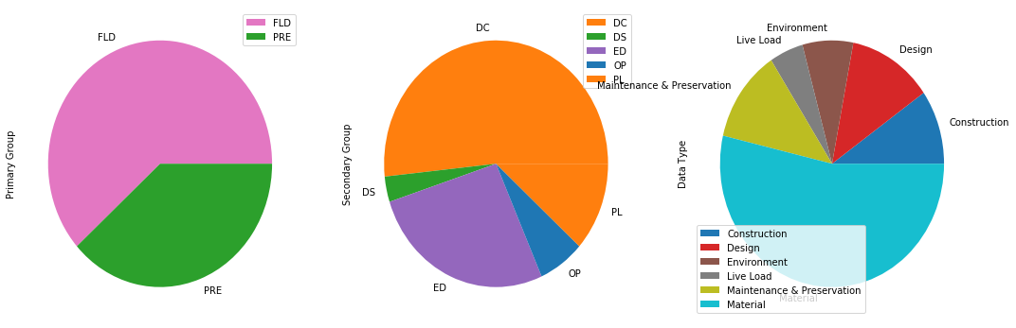

#### View Summary of PREVISIT Data Sources¶

In [4]:

filter_key = 'PRE'  
  
pre = df[df['Primary Group'] == filter_key]  
  
pre.loc[:,cols].apply(pd.value_counts).plot.pie(subplots=True,figsize=(18,6))

Out[4]:

array([<matplotlib.axes._subplots.AxesSubplot object at 0x0A156E90>,  
 <matplotlib.axes._subplots.AxesSubplot object at 0x0A3DA250>,  
 <matplotlib.axes._subplots.AxesSubplot object at 0x0A18E170>], dtype=object)

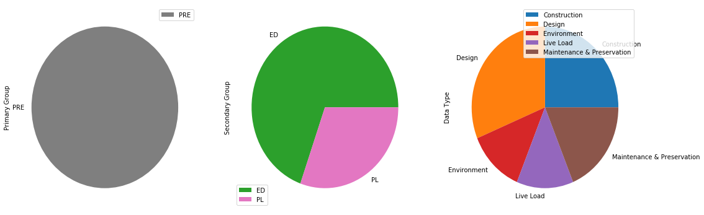

#### View Summary of FIELD VISIT Data Sources¶

In [5]:

filter_key = 'FLD'  
  
fld = df[df['Primary Group'] == filter_key]  
  
fld.loc[:,cols].apply(pd.value_counts).plot.pie(subplots=True,figsize=(18,6))

Out[5]:

array([<matplotlib.axes._subplots.AxesSubplot object at 0x0A1ECA50>,  
 <matplotlib.axes._subplots.AxesSubplot object at 0x0A219BD0>,  
 <matplotlib.axes._subplots.AxesSubplot object at 0x0A239AD0>], dtype=object)

